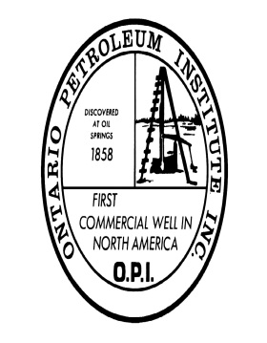
EPEX 2019 / OPI’s 57th Annual Conference
April 29 – 30, 2019
Best Western Lamplighter Inn, London, Ontario

SPONSOR FORM
If your company would like to be a sponsor for this year’s conference, please use the form below and remit to OPI. All sponsors will have their name on a sign near the registration table in the event program guide, and acknowledgement in the OPI newsletter and website. In addition, special sponsorships will be given verbal recognition and/or table signs.
We would like to support OPI’s annual conference with the following contribution:
Suggested Donations: Platinum Sponsor: $2,000 or more ______________ Gold Sponsor: $1,000 or more ______________
Silver Sponsor: $ 500 or more ______________
Bronze Sponsor $ 250 or more ______________
Friends of OPI Under $250 ______________

Program Ad (full-page) $ 300 ______________
Program Ad (half-page) $ 150 ______________

Would you like your donation to be designated in any special way? Areas of specific sponsorship for donations are:
Welcome to the Industry Reception / Tuesday Morning Breakfast / Tuesday Morning Break / Tuesday Luncheon / Tuesday Late Afternoon Wine & Cheese / Brewery Networking Event / Audio Visual / Technical Sessions / Keynote Speakers / Proceedings Videos

(Note: Sponsorship opportunities will be offered to previous sponsors on a right of first refusal basis. Please call for availability of specific opportunities.)

I would like to support the OPI 57th Conference & Trade Show in the amount of ____________ by sponsoring the following event: _______________________________

Company Name: __________________________________
Contact: _________________________________________
For more information, please contact:
Ontario Petroleum Institute Inc.
203-555 Southdale Rd. E., London, ON N6E 1A2
(519) 680-1620
opi@ontariopetroleuminstitute.com

